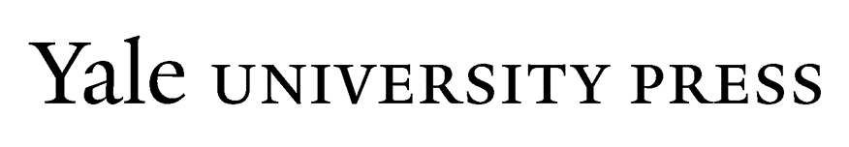

Manuscript Submission Checklist
Please complete the checklist and submit it with your final manuscript. This form is also available as a PDF.

Text
Word count—including notes, bibliography, tables, and captions—is within contract length
Manuscript is complete except for an index
Files are named and numbered according to the guidelines
Printout matches files exactly and is paginated in one continuous sequence
Notes are numbered 1-up by chapter
Illustrations, tables, and boxes, if any, are placed in separate files, with “callouts” in the text
If any boxes above are not checked, explain exceptions: _______________________________________________________
Operating system used (Mac/Windows): __________________________
Word-processing software used (Microsoft Word/[specify other]): _______________
Fonts used: __________________________

Illustrations
Illustration count is within contract length
Illustration files are acceptable in format (e.g., TIFF, EPS) and resolution (300 ppi)
Files are named and numbered according to the guidelines
Illustration captions are supplied as a separate list and include all necessary credit lines
Art log is supplied
Numbered printouts of electronic art, matching files exactly, are interleaved with final labeled non-electronic artwork, if any, to produce one complete set of “original” illustrations
Photocopies of all illustrations are supplied, with figure numbers and cropping clearly marked
If any boxes above are not checked, explain exceptions: _______________________________________________________

Permissions and Releases (in each case, indicate Y for Yes or N/A for Not Applicable):
All necessary permissions or work-for-hire agreements for illustrations are obtained: _______
All necessary permissions for tables are obtained: ________
All necessary permissions for quoted prose are obtained (more than 300 cumulative words or a complete chapter, letter, or story from a book-length work published or translated after 1922): ________
All necessary permissions for poetry or song lyrics published or translated after 1922 are obtained: _______
All necessary permissions for unpublished letters, diaries, or manuscripts are obtained: __________
All necessary releases for interviews are obtained: ___________
If any portion of your work is a translation, rights to original work are obtained, and there is a work-for-hire agreement or contract for the translation: _________
If your book is an edited volume or contains items written by someone else (e.g., foreword), contributors’ agreements are obtained: _________
If any answers above are not Y or N/A, explain exceptions: ___________________________________________________
Does your work contain statements of fact about a living person or existing organization which might damage their reputation, and which the person might not wish to have published? Indicate no or explain: _______________________________________________________________________________

